Academic Year | 2025 - 26 | Experiment No. | 8
Course & Semester | S.E. – Sem. III | Subject Name | Analysis of Algorithm
Experiment Type | Software Performance | Subject Code | 25PCC12CS05

Name of Student: | Atharva Dharmendra Jagtap | Roll No.: | 10937
Date of Performance: | 01-11-2025 | Date of Submission: | 03-11-2025
LO Mapping | 25PCC12CS05.1: Analyze the time and space complexity of algorithms.  25PCC12CS05.5: Apply backtracking and branch and bound strategies to solve a problem.

Indicator | Poor | Average | Good
Timeline Maintains submission deadline (3) | Submission not done (0) | One or More than One week late (1-2) | Maintains deadline (3)
Completion and Organization (3) | N/A | Document is just acceptable (1-2) | Completed whole document and neatly organized (3)
Program Performance (2) | Could not perform at all (0) | Implemented few parts (1) | Full implementation (2)
Knowledge In depth knowledge of the Experiment (2) | Unable to answer questions (0) | Unable to answer few questions (1) | Able to answer all questions (2)

Assessment Marks:
Timeline
Completion and Organization
Program Performance
Knowledge

Total: (Out of 10)
Teacher’s Sign: Student Sign:

Experiment No. 8
AIM: To Implement N queen problem
THEORY:
The N-Queens problem is a classic challenge where the task is to place N queens on an N×N chessboard such that no two queens threaten each other. A queen can attack another if they are in the same row, column, or diagonal. The goal is to arrange the queens in a way that satisfies these constraints.
Key Concepts:
- Backtracking: A common method to solve the N-Queens problem, where queens are placed one by one on the chessboard. If a conflict is detected, the algorithm backtracks to try a different placement.
- Diagonal Conflict: Queens must not share the same diagonal, so two diagonals are tracked for conflicts: the main diagonal (i - j) and anti-diagonal (i + j).
- Recursive Search: The problem is typically solved by placing queens row by row and backtracking when necessary.
ALGORITHM:
• Input the size of the board (n):
- The board will have n rows and n columns, where n is the number of queens and the board size.
• Initialize the board:
- Create an array board[] of size n. This array will store the column positions for queens on each row. For example, board[i] = j means a queen is placed at row i and column j.
• Check if it's safe to place a queen:
- For each position (row, col), check whether placing a queen at that position will result in a conflict with any previously placed queens.
- Ensure the queen is not in the same column or diagonal as any other queen.
• Backtracking function (solveNQueens):
- Base Case: If all n queens have been placed (i.e., row == n), print the current board configuration.
- Recursive Step: For each column in the current row, check if placing a queen is safe using isSafe(). If it is safe, place the queen, then recursively attempt to place queens in the next row.
• Print the board configuration:
- For each solution found, print the board where 'Q' represents a queen and '.' represents an empty space.
• End:
- Free the dynamically allocated memory for the board after the program execution is completed.
CODE:
#include<stdio.h>
#include<stdlib.h>

int board[20] = {0}, count = 0;;

void printsol(int queens)
{
int i,j;
printf("\n\n Solution:%d\n", ++count);
for(i=0; i<queens; i++)
{
for(j=0;j<queens;j++)
{
if(board[i] == j)
printf(" Q ");
else
printf(" - ");
}
printf("\n\n");
}
}

int issafe(int row, int col)
{
int i;
for(i=0; i<row; i++)
{
if(board[i]==col || abs(board[i]-col) == abs(i-row))
return 0;
}
return 1;
}

void placequeens(int row, int queens)
{
int col;
for(col=0;col<queens;col++)
{
if(issafe(row, col))
{
board[row] = col;
if(row == queens-1)
printsol(queens);
else
placequeens(row+1,queens);
}
}
}

void main()
{
int queens;
printf("Enter number of Queens:");
scanf("%d", &queens);
placequeens(0, queens);
}

OUTPUT:
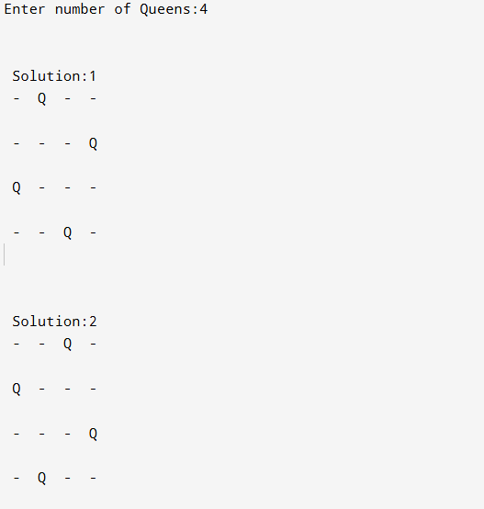
POST LAB QUESTIONS

1. Why is backtracking suitable for the N-Queens problem?
Backtracking is ideal for constraint satisfaction problems, where we need to explore multiple possible configurations but only keep the ones that meet specific constraints.
In the N-Queens problem:
- You must place N queens on an N×N chessboard so that none attack each other.
- Each queen must satisfy constraints:
  - No two queens share the same row, column, or diagonal.
- The solution space grows exponentially (O(N!) possibilities).
- Backtracking prunes invalid paths early — if a partial configuration violates any rule, it immediately backtracks instead of exploring further.
- It systematically explores all valid placements row by row (depth-first search), ensuring all solutions are found efficiently.

2. How do you identify problems suitable for backtracking?
A problem is well-suited for backtracking when it satisfies the following properties:
Criterion | Description | Example
Combinatorial search | The problem involves generating and testing combinations or permutations. | N-Queens, Sudoku, Permutations
Constraints to satisfy | There are conditions that must be true for a valid solution. | No two queens attack each other
Partial solutions can be tested | You can detect early if a partial solution violates constraints. | Placing a queen that threatens another
Multiple solutions possible | There can be one or more valid configurations. | N-Queens, Maze solving
Search space is large but structured | The problem can be represented as a tree or graph of possible states. | Decision trees, Graph coloring

3. Why does the problem have no solution for N = 2 and N = 3?
- For N < 4, the board is too small to separate queens by both row, column, and diagonal simultaneously.
- Hence, no arrangement exists that satisfies all constraints

CONCLUSION:
The N-Queens problem demonstrates the effectiveness of the backtracking algorithm in solving complex constraint-based problems through systematic exploration and pruning of invalid states. By recursively placing queens row by row and validating each move, backtracking efficiently searches the solution space without redundant computations.

